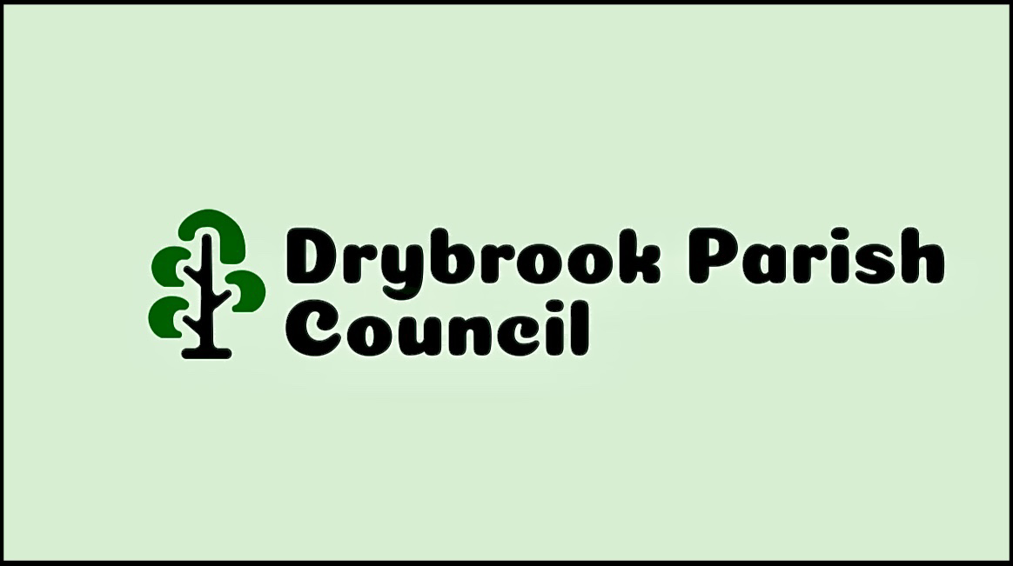

**DRYBROOK PARISH COUNCIL PLANNING COMMITTEE**

**TERMS OF REFERENCE**

The Planning Committee is constituted to consider and respond on behalf of Drybrook Parish Council - as Consultee; to all Applications for Planning Permission made under the Town and Country Planning Act 1990 (this may also include Applications for Listed Building Consent made under the Planning (Listed Buildings and Conservation Areas) Act 1990) and Planning Appeals, referred to the Parish Council by the Forest of Dean District Council (FODDC).

**MEMBERSHIP**

Membership shall consist of a minimum of 3 Elected Members or Co-Opted Members of the Full Council and will be elected to serve on the Committee at the Annual Parish Council meeting of Drybrook Parish Council. The quorum of the Planning Committee shall be 3 members.

**AREAS OF RESPONSIBILITY**

The Planning Committee has the delegated authority and responsibility from Drybrook Parish Council:

* To consider all planning applications.
* To study relevant plans, visit relevant sites (if necessary) and consider any comments from members of the Parish before coming to a decision.
* To make representations to Forest of Dean District Council (FODDC) on behalf of Drybrook Parish Council.
* To ensure that any objections or recommendations are based solely on planning criteria.
* To consider environmental aspects when considering planning applications.
* To make representations in respect of Appeals against the refusal of Planning Permission.
* The Planning Committee Members may canvas opinion for and against the application and consult with other relevant bodies/persons to assist with fair determination of applications.
* On site meetings may be arranged by the Chairman of the Committee and where an on site meeting is arranged all members of the Committee and the Council shall be notified, but not all have to be in attendance.
* To deal with any other planning related matter that a meeting of the Full Council considers  appropriate to be referred to the Planning Committee. All powers shall be exercised in accordance with any Standing Orders, or directions given, by the Parish Council.
* To attend planning training sessions as offered by the Planning Authority, and/or Gloucester Association of Parish and Town Councils (GAPTC) and to read all relevant documentation to ensure that the Committee is aware of current legislation and regulations.
* The Chairman of the Committee will ensure a monthly report is made available at each Parish Council Meeting.
* To have the ability and option to advertise and elect interested non Council members – should it be deemed necessary by the Full Council and the Planning Committee.
* **MEETINGS**

The Parish Clerk shall circulate all planning Applications to the Planning Committee as soon as possible after receipt. The Application Information will be circulated by the Clerk to the Committee by email, and hard copies of all Planning Applications will be received as ‘hard copies’ to the Clerk via Forest of Dean District (FODDC). Council Planning Applications will usually be considered by the Planning Meeting discussion conducted prior to Full Council Meetings. However, the Chairman of the Planning Committee *may* call Planning Committee meetings as and when necessary. The Planning Committee will decide whether they have recommendations of ‘Support’ or ‘Objection’ or ‘No Recommendation’ to make in relation to each Planning Application.

If three Councillor’s consider an application to be of great importance to the village, they may ask the Committee for a deferral to pass the decision either to the next Full Council Meeting of the Parish Council, or if a time regulated decision is required arrange for an Extraordinary Meeting to decide on the response. Where an ‘Extraordinary meeting’ has been called it will be open to the public.

The Planning Committee has an obligation to ensure that all comments received prior to the Full Council meeting, from all relevant parties, applicants and objectors, for planning applications are considered at the meeting. Any Planning Applications that cannot be considered prior to the District Planning timeframe by the Full Council, the Clerk will ask the FODDC for an extension of time for the Planning Committee Decision.

**RESPONSES**

The Chairman of the Planning Committee will communicate any application decisions to the Clerk by email detailing the Planning Committee’s recommendations to FODDC and will ensure that communication arrives within the timescale for each application. Should the Chairman not be able to communicate a time-regulated response, a Committee Member may be elected to do so in the Chairman’s absence/place. Where an application is subject to an Appeal, the Committee is authorised to make written representation via the Clerk or to elect a Member of the Committee and/or Clerk to attend the hearing (if necessary).

**REVIEW**

The election of Committees and their Terms of Reference are to be reviewed annually at the Annual Parish Council meeting of Drybrook Parish Council.

**Draft 1**

**11/10/23**